59.02.05a
To John Lindley
RBG Kew, Archives, Letters to John Lindley, vol. 2 (L-Z) ff. 659-660.

Melbourne botanic and zoologic
Garden, 5. febr 1859
My Dear Sir
A few days ago I had the great pleasure of receiving your highly valuable "folia orchidacea", a really classic work, for the transmission of which I beg to tender you my grateful acknowledgement. It will be of great service to me in future writings on this noble Order, altho' possibly we may regard the orchid-flora of Australia now as fully known, not even the Calamus jungles of Eastern Australia having aforded many new parasitical species, whilst the terrestrial ones disappear in the hotter zone. The few novelties I possessed are described in the 4. No of my fragmenta, which will be sent to you by the first opportunity. Probably you will be displeased with my having subjugated the genus Gunnia to Sarcochilus. But I really believe, you would not have separated it at the time, when it was established, had Sarcochilus been known except from the very imperfect circumscription given by RBr. Some vituperation may fall on me in having not the worthy Gunn's name attached to the species, but what shall I say, if Dr Hooker describes the sepals as yellow, whilst they are quite green, color not varying in this order except into white. I sent to our friend Dr Hooker 12 months ago previous to my describing the species a specimen for identification and asked Mr Gunn & Dr Milligan also for a specimen of the Tasmanian plant. The latter friend had mislaid them, and the former having as he says "the misfortune of being a legislator"! delayed sending them, until after I had published my notes. The occurrence of the elegant little Dendrobium Milligani in Tasmania & Bass's Straits will interest you.
I have now restored Gunn's claim on a genus being named in acknowledgement of his very meritorious botanical exertions by choosing as Gunnia a n.g. of Portulaceae brought just home by Mr Babbage from the N.W. of South Australia. This gentlemans bot collection contains besides an other well marked genus Babbagia, (of Salsolaceae) differing from Kochia in producing 2 wings only, both vertical; - then different species of known genera, Helichrysum, Eremophila, Trichinium, Hibiscus &c, amongst which the Eremophila Macdonnelli is truly elegant. There will be a separate report issued on this collection, in the way as on Mr Gregory's collection formed in 1858 on Coopers Creek.
My own multifarious duties on this establishment permitted me only for a very short time to seek recreation in a botanical tour to the S.W. parts of the alps, where I discovered a [new] range encircling an auriferous country & where I likewise obtained some botanical novelties, amongst which the fine Goodenia M'Millani is the most desirable for garden introduction.
With veneration & best wishes for your welfare, I remain, dear Professor, your humble
[Ferd] Mueller

I will do my best to find for your favorite gardener suitable employment. I will thankfully avail myself in any future orchidological discoveries to see them published through your kindness in the L.S. journal. For a sending of seeds from the Hort. Soc. many thanks. I [shall] soon reciprocate for them. Also accept my sincere thanks for you troubles about acorns - I will write to our Colonial Agent, who may be able to send them officially, other wise our patriotic friends Edw. Wilson Esq or W. Westgarth Esq, City Bank Chambers 20 Threadneedle Street would, I feel sure, gladly forward any thing calculated to be a boon to this country.
I am just dividing this years duplicates into collections, of which I shall be happy to send you one. If you can favor me with a few duplicates from any tropical or subtropical country of the eastern hemisphere, I shall be greatly delighted.

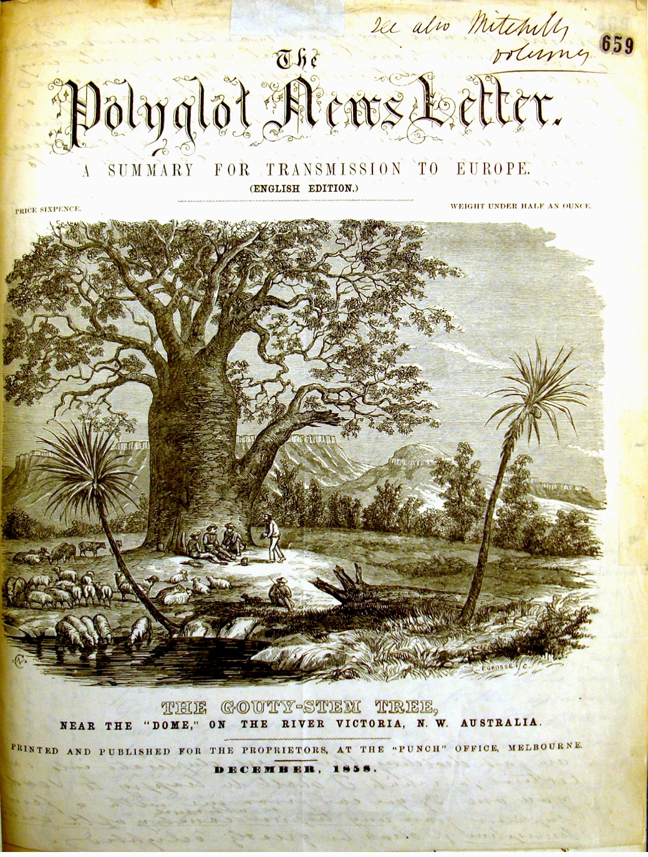

Babbagia
Calamus
Dendrobium Milligani
Eremophila Macdonnelli
Goodenia M'Millanii
Gunnia
Helichrysum
Hibiscus
Kochia
Portulaceae
Salsolaceae
Sarcochilus
Trichinium

"Folios" 659 and 660 are a single folded sheet. The text of the letter begins on the front of f. 660, with postscripts continued on the back of f. 659. The front of f. 659 is occupied by an illustration engraved by Frederick Grosse and signed by him ‘F. Grosse [l/c]’. 59-02-05a_image01.jpg The 'Gouty-stem tree' depicted is Adansonia gregorii, formally described by M (B57.01.01, p. 14) from specimens collected near the Victoria River during the North Australian Exploring Expedition. The image with the annotation (by J. Lindley?), 'see also Mitchells volumes’ is reproduced with the kind permission of the Board of Trustees of the Royal Botanic Gardens, Kew. It may not be reused unless this is explicitly agreed to in writing by Kew. Lindley named another Australian 'bottle tree', Delabchea rupestris, in Mitchell (1848), p. 154-5; it is illustrated on p. 154.
Lindley (1852-9). M is probably referring to the first section of Part VIII of this work, which is marked as having been published on 1 November 1858 after an interruption of several years. (Subsequent sections appeared in January and February 1859, and the title page of the Part is marked February 1859.) The final two parts, Parts VIII and IX, are missing from the bound copy of the work in the library of the Royal Botanic Gardens Melbourne but there is a separate, unbound copy of Part IX inscribed ‘Dr Ferd. Müller’.
B59.02.03, pp 87-90.
B59.02.03, p. 90: Lindley's Gunnia australis was renamed Sarcochilus gunnii.
See M to J. Hooker 15 December 1858 (in this edition as 58-12-15a), where he says that it was to Lindley that he sent specimens 'January last'.
M to R. Gunn, 22 October 1858.
Letters not found.
Gunn was a member of the House of Assembly for the constituency of Selby (ADB).
B59.04.02.
B59.04.03, in which M erected Gunnia (G. septifraga), p. 9.
Obscured by binding.
The signature is written in a small space at the very bottom of the sheet.
Person not identified; letter requesting M's help not found.
I will ... [shall] written in the left margin, f. 660 front. [shall] is torn at the fold which has been inserted into the binding.
soon ... country is written on the back of f. 659, above the back of the engraving, which shows through the thin paper. I am just dividing... greatly delighted is written below the back of the engraving.

